[](http://sipl.technion.ac.il/)הטכניון - מכון טכנולוגי לישראל



הפקולטה להנדסת חשמל

המעבדה לעיבוד אותות ותמונות

**דו"ח סיכום פרויקט: ב'**

מערכת לומדת לזיהוי ילדים שנשכחו ברכב

Machine Learning of a Piezoelectric Sensor for Detection of Children Abandoned in Cars

מבצעים:

**לי אדר Li Adar**

**תום בר Tom Beer**

מנחים:

**אלון עילם Alon Eilam**

**יאיר משה Yair Moshe**

**סמסטר רישום: חורף תשע"ז**

**תאריך הגשה: ‏יולי 2017**

P 3560-2-17

**Table of Contents**

Abstract 4

Introduction 5

The Data 6

Prior Art and our Proposed Approach 10

Feature Extraction and Selection 11

Classification 13

Hysteresis 16

Results 17

Feature extraction block 17

Selecting the optimal wavelet 18

Optimal decomposition level 21

Optimal number of wavelet coefficients 22

Data classification block 23

SVM and logistic regression 23

Naïve Bayes and LDA 23

Decision tree 23

KNN 24

Tuning the hysteresis level 26

Error analysis 27

Passenger detection 28

Real Time Implementation 31

Discussion and Conclusion 32

Bibliography 33

Appendix A: Project Documentation 34

**List of Figures**

Figure 1: Anticlockwise from upper left corner; closed sensor package, open sensor package, custom designed auxiliary board, Arduino microcontroller 6

Figure 2: An illustration of three different kid signals 8

Figure 3: An illustration of three different noise (no kid) signals 8

Figure 4: Illustration of the Hierarchical structure of the subspaces 10

Figure 5: Illustration of the recursive structure of the transform 11

Figure 6: Demonstration of a maximum margin hyperplane 12

Figure 7: Demonstration of classification with different $k$’s 13

Figure 8: Example of a binary decision tree 14

Figure 9: Illustration of the hysteresis effect on output decisions 16

Figure 10: Demonstration of the best performing wavelet 18

Figure 11: Performance of different wavelets 19

Figure 12: Demonstration of different Daubechies wavelets 20

Figure 13: Performance for all possible decomposition levels 21

Figure 14: Performance for different number of wavelet coefficients 22

Figure 15: Performance as function of number of nearest neighbors 23

Figure 16: Performance as function of the distance metric 23

Figure 17: Performance as function of the distance weight 24

Figure 18: Performance as function of the hysteresis level 25

Figure 19: Demonstration of the difference between signals of passengers and empty seats while driving 27

Figure 20: Performance as function of the hysteresis level for a driving car 28

**List of Tables**

Table 1: Summary of acquired data 7

# Abstract

In this project, we designed a system for the detection of children forgotten in cars. This system uses measurements from a piezoelectric sensor installed in the car’s seat. The generated signals are processed by a machine learning algorithm which includes the following blocks: preprocessing, feature extraction, classification and result filtering. This algorithm achieves performance of a single in more than 10,000 signal instances, on our acquired dataset. We implemented the above algorithm on a real time micro-controller, to produce a fully operational standalone device.

בפרויקט זה, תכננו מערכת לזיהוי שכחה של ילדים ברכב. מערכת זו משתמשת במדידות מחיישן פיאזו-אלקטרי הנמצא במושב הרכב. אותות החיישן עוברים עיבוד על ידי אלגוריתם לומד הכולל את הבלוקים: עיבוד מקדים, חילוץ מאפיינים, סיווג וסינון התוצאות. אלגוריתם זה משיג ביצועים של שגיאה אחת כל פחות מ-10,000 אותות, על פני מאגר האותות שהקלטנו. מימשנו את האלגוריתם הנ"ל על מיקרו מעבד העובד בזמן אמת, כדי ליצור מערכת מבצעית ועצמאית לחלוטין.

# Introduction

The problem

Forgotten Baby Syndrome (FBS) is a term most parents have hopefully never heard. It refers to accidentally leaving a baby or young child in a locked car, often with tragic results. In recent years, more and more children are forgotten in the car by their parents or caregivers, and attempts to eradicate this problem have been found fruitless.

For example, in Israel 19 children have died in 400 such cases, in the last 8 years only, and in the US, there have been close to 40 heatstroke deaths of children left in cars every year.

Many awareness raising campaigns have been launched in different countries, but approaches relying on the human factor to confront this phenomenon will never be perfect, as people eventually fail at one point or another.

The solution

A technological approach is essential in solving the situation. We believe that a sensor based system in the vehicle can dramatically increase survival rates in such cases.

In this project, we took part in the development and implementation of a fully operational standalone system. It measures pressure signals from under the child’s seat and outputs a decision according to a statistical algorithm. Output signals are sent to the vehicle’s peripheral mechanism, to activate the horn, unlock the doors and open the windows.

This report presents the different elements of the system, describes the design considerations we faced during development and documents our work for later reproduction.

We showed that it is possible to reach error rates of around 0.01% for output decisions.

# The Data

Ballistocardiography

Ballistocardiography (BCG) is a non-invasive method for the measurement of body motion generated by the ejection of blood at each cardiac cycle. It was discovered and introduced in the 1940’s by Dr. Isaac Starr (see‎[1]) and has attracted intense research focus until the late 20th century. After that time, this method has faded away, mainly due to a lack of standardization of measurement methods and a lack of deep understanding of the physiological basis of BCG signals. However, this methodology seems to enjoy a revival and resurgence in the last decade, thanks to new technological advances regarding the sensor mechanisms.

In this project, we designed and implemented a system that relies on BCG signals to discriminate between presence and absence of children in a vehicle.

Measurement Apparatus

A specific apparatus was designed for the task. Its core is a piezoelectric sensor, which converts the ballistic forces from the environment to electrical charge via the piezoelectric effect. This sensor is encompassed in a custom designed package, suitable in shape and size to be placed on child safety seat (see Figure 1).

Data acquisition

The sensor’s analog signal is fed into the Arduino microcontroller (see Figure 1) and sampled by its analog-to-digital converter (ADC) at a rate of 1 KHz. All data used in this project was acquired and recorded by us. The data was acquired in some different schemes involving children, grownups, or empty seats, in a driving car, a still car or in an office. Table 1 summarizes the different recording types. Due to the low availability of children and parents willing to participate in the data acquisition, we decided it be better if most of their recording was done indoor and not in a car. In this way, we have managed to acquire a significantly larger amount of data.

The real-time signal processing described in 29 is done on the same microcontroller.

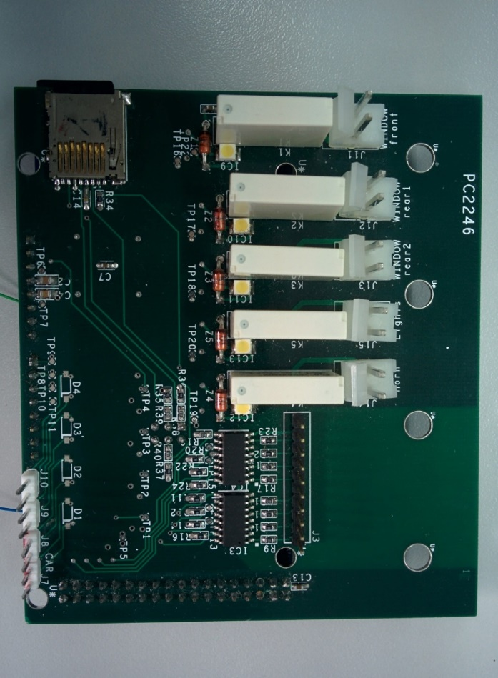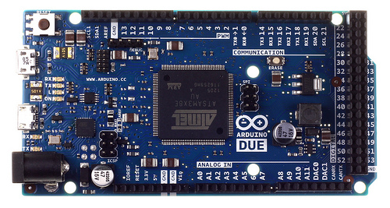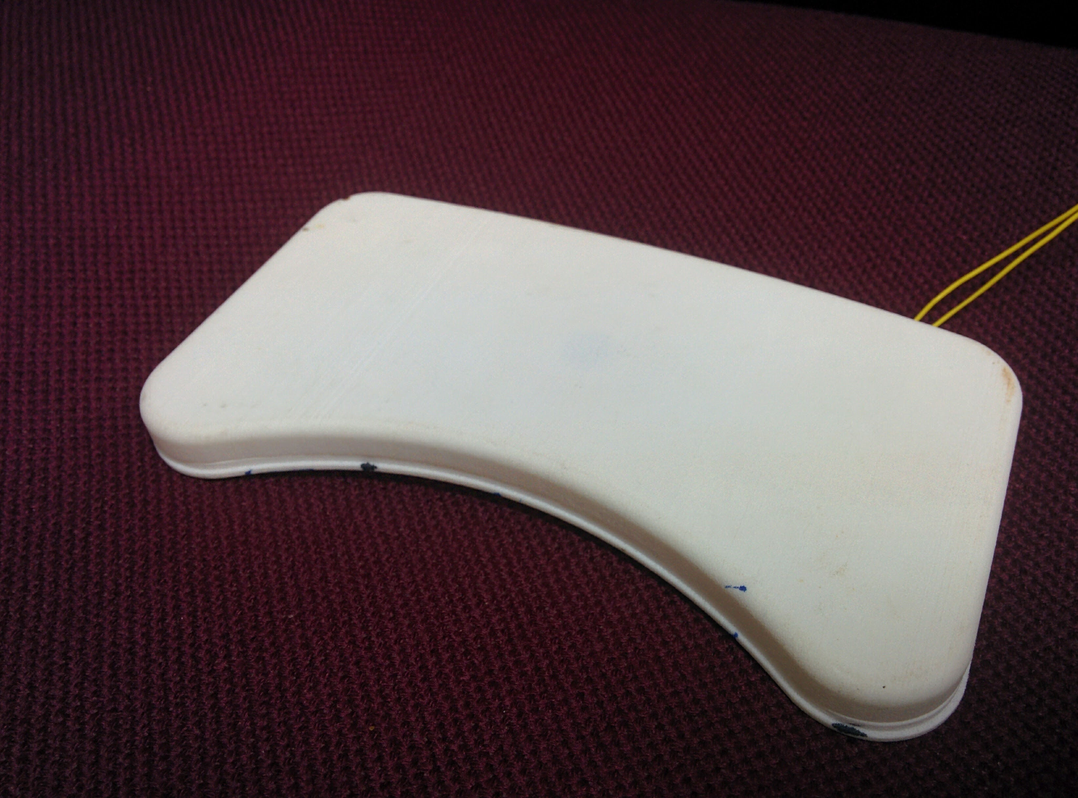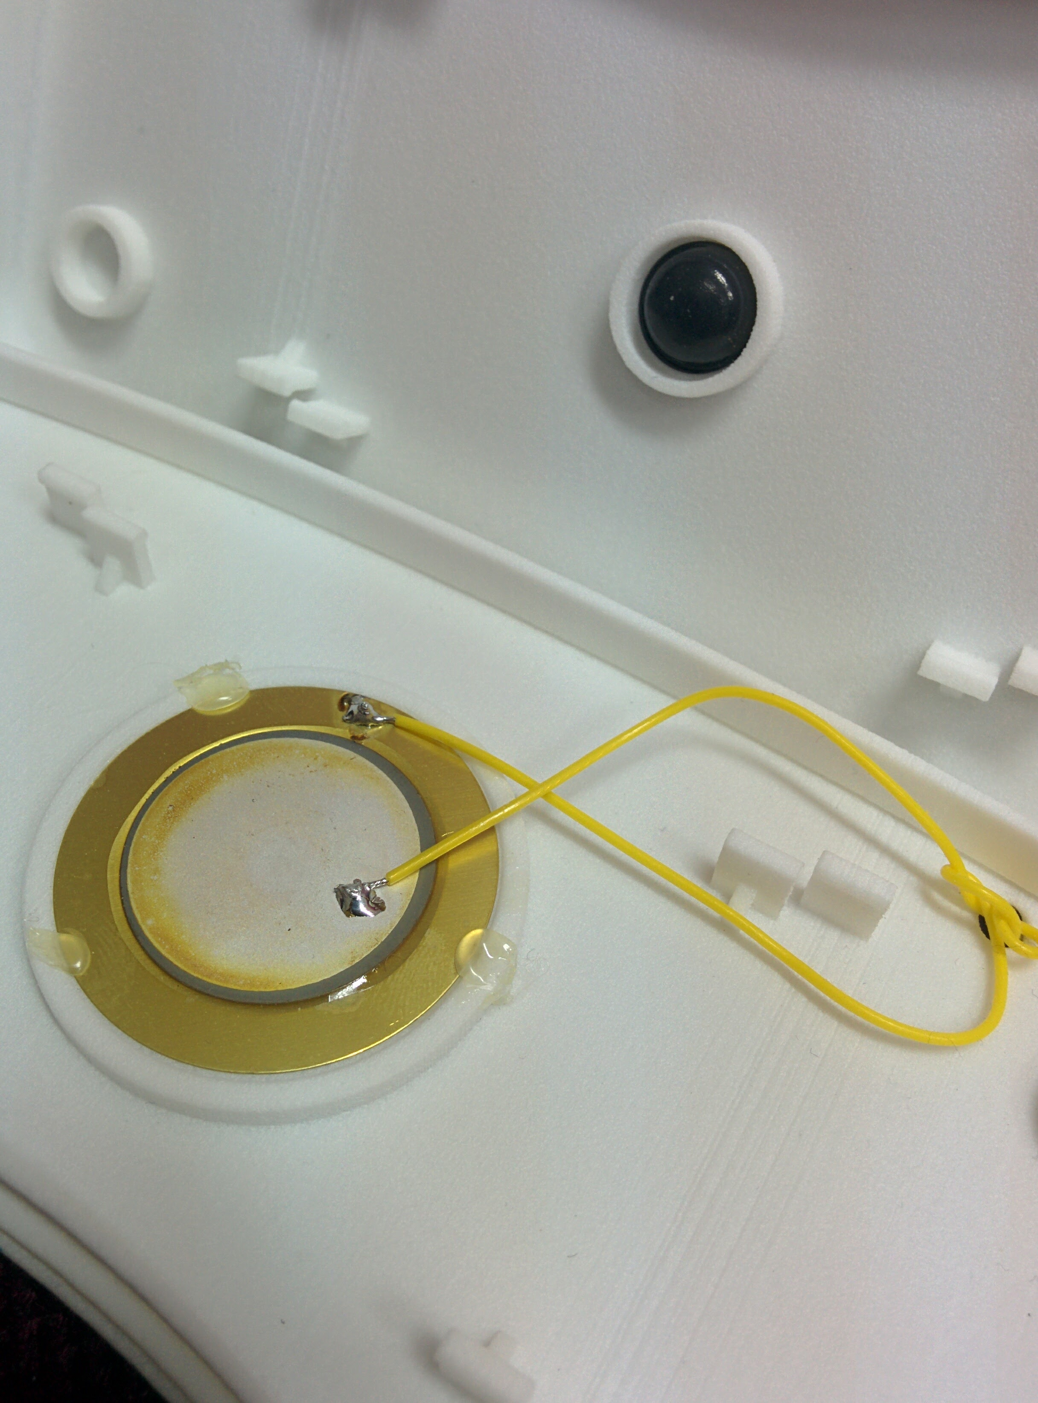

Figure 1: Anticlockwise from upper left corner; closed sensor package, open sensor package, custom designed auxiliary board, Arduino microcontroller

|  |  |  |
| --- | --- | --- |
| Data type | Amount recorded [minutes] | Comments |
| Children in kindergarten | 45 | Indoor, on a couch |
| Children in a still car | 17 | Half with engine off, half on |
| Empty seat in a still car | 116 | Half with engine off, half on. Various locations: some quiet, some not |
| Grownup on an office chair* | 156 |  |
| Grownup in a driving car** | 94 | On highway 2 |
| Children in a driving car** | 25 |  |
| Empty seat in a driving car** | 70 | On highway 2 |
| Sensor under a load of bags in a driving car** | 104 | On highway 2 |

Table 1: Summary of acquired data

Remarks:

* This dataset will be left out of training, unless it proves useful

** These datasets will not be used for child detection, but for seatbelt detection (see page 16)

In terms of dataset size for the machine learning algorithms, the above recording time is translated to 4970 samples (counting only the main recordings, i.e. the first three rows in the table).

Characterization of the data

Relying on the theory of BCG, it is assumed that all vital information (of the kid signals) is in the frequency band of 1Hz to 20Hz. Naturally, our recorded signals have reasonable spectral content outside this range, due to child motion, sensor noise, engine vibration and more. Figure 2 and Figure 3 show three children and three noise recordings, to demonstrate the large variability of the signals.



Figure 2: An illustration of three different kid signals

Figure 3: An illustration of three different noise (no kid) signals

# Prior Art and our Proposed Approach

Baseline: dual sensor spectral analysis

Prior to our work, a different approach was tested, one that is based on the spectral analysis of the signals. It relies on simultaneous measurements from two independent sensors; the first measures the seat activity, the second outputs a reference signal from the car trunk. Spectral content of both signals is extracted, and the decision rule is to threshold the ratio between energy in predefined frequency bands of both signals to a fixed value. If the ratio between the seat signal to the reference signal exceeds the threshold, child presence is declared.

Our approach: single sensor machine learning

In this work, we introduced two central changes as compared to the above method. The first was to remove the reference signal from the system. This sensor complicates the installation and raises the system’s cost. More than that, we assumed it was not necessary for proper functionality of the system.

The second major revision was to apply a machine learning approach, rather than a fixed decision rule as in the previous attempt.

We focused a large part of our activity on finding the optimal machine learning algorithm. This task can be broken down into two distinct steps:

1. Extracting the most descriptive features from the data
2. Selecting and tuning the most suitable classifying algorithm

The following sections describe this attempt, from theory to results.

# Feature Extraction and Selection

Feature extraction is a process for reducing the amount of resources required to describe a set of data. It refers to an array of dimensionality reduction techniques that aim to efficiently represent the relevant parts of the data as a compact vector of variables or attributes. These informative attributes are constructed or generated from the raw data by different transformations.

Feature selection is a later step that involves choosing a subset of the extracted features, removing redundant or irrelevant attributes without incurring a significant loss of information.

This entire process is done to simplify models, shorten training times and lower operational complexity. Apart from that, it also minimizes the risk of overfitting by improving the ability to generalize and thus to avoid the curse of dimensionality.

In this work, we focused on two kinds of features. The first is time-frequency transformations, specifically discrete wavelet decomposition, and the second was statistical variables.

Discrete Wavelet Transform

The wavelet transform is a powerful tool for signal representation. Unlike the Fourier transform which is based on infinite length waves (sinusoids) and analyzes the frequency components of the signal, this transform is based on small waves (wavelets) and captures both the location (time) and frequency information of the signal.

A function $Ψ\left(t\right)$ is called a mother wavelet if it can be used to construct a Hilbert basis by means of dyadic translations and dilations:

$$Ψ_{j,k}\left(t\right)=\frac{1}{\sqrt{2^{j}} }Ψ\left(\frac{t-k{*2}^{j}}{2^{j}}\right) j,k ϵ Z$$

In a similar manner, we define another family of functions called scaling functions:

$$φ_{j,k}\left(t\right)=\frac{1}{\sqrt{2^{j}} }φ\left(\frac{t-k{*2}^{j}}{2^{j}}\right) j,k ϵ Z$$

These two families are orthonormal to one another; Subspaces of $Ψ$ and $φ$ are disjoint. Higher order subspaces of $Ψ$ and $φ$ are nested in lower order subspaces of $Ψ$ and $φ$, respectively, as illustrated in Figure 4. Denote $W_{j}=span\left(Ψ_{j,k}\left(t\right)\right)$ and $V_{j}=span\left(φ_{j,k}\left(t\right)\right)$. Then:

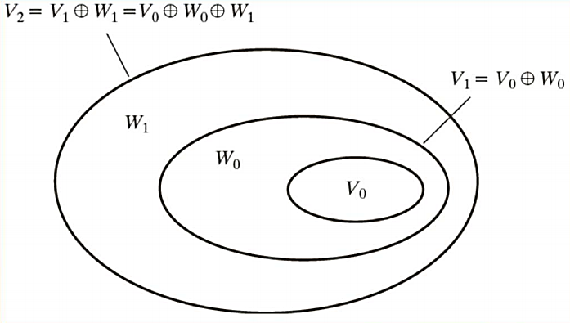

Figure 4: Illustration of the Hierarchical structure of the subspaces

We now turn to define the discrete wavelet transform for any function $f(n)$:

$$C_{φ}\left(j_{0},k\right)=\sum_{n}{f\left(n\right)}φ_{j_{0},k}\left(n\right) C_{Ψ}\left(j,k\right)=\sum_{n}{f\left(n\right)}Ψ_{j,k}\left(n\right)$$

$C_{φ}$ are called the approximation coefficients, and $C_{Ψ}$ are called the detail coefficients of the signal. If we continue to transform the signal represented by the approximation coefficients, we obtain the discrete wavelet decomposition. This is a series of approximations of growing detail level. The process is schematically illustrated in Figure 5.

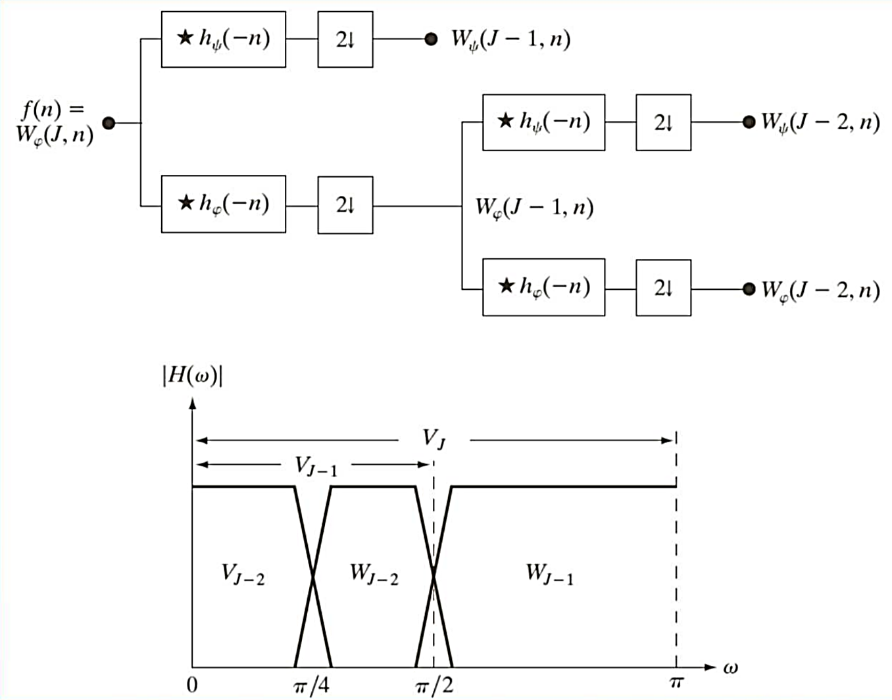

Figure 5: Illustration of the recursive structure of the transform

By continuing to decompose the signal to its finest level of detail (corresponding to frequency), we have a vector of coefficients the length of the original signal. We truncate it and remove any but the first K coefficients (K is an algorithm parameter, see page 21), and use the remaining values as a feature vector for the machine learning classifier.

Apart from the wavelet coefficients themselves, we also measure some statistical characteristics of the transform: for every frequency band we compute the maximum, the minimum, the mean and the standard deviation of the band’s coefficients, and add them to the signal’s feature vector.

# Classification

We simulated and tested some of the most widely used classifying algorithms. The following section provides an overview of the tested algorithms.

1. Linear Discriminant Analysis (LDA)

This model is an optimal Bayesian classifier under the assumption that both classes are normally distributed with equal variance. When classes are assumed not to have the same variance, a similar model is used, called quadratic discriminant analysis. After class means and variances are estimated (e.g. using maximum likelihood), the optimal classifier is:



Where:

$\vec{x}$ Is the vector of input features

$\vec{μ_{i}},\underline{Σ}$ Are the estimated class means and variance

$n_{i}$ Are the proportional frequencies of classes

We can see that the optimal Bayesian classifier under this model is just a linear combination of the input feature vector, so this classifier is light computationally-wise.

1. Support Vector Machine (SVM)

This linear classifying algorithm finds the maximum margin hyperplane that seperates between classes, as illustrated in the simple two dimensional case in Figure 6.

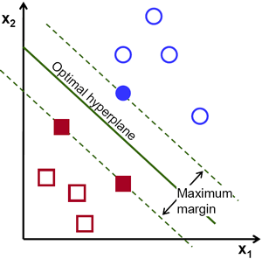

Figure 6: Demonstration of a maximum margin hyperplane

If the data is not linearly seperable, a soft margin is imposed which penelizes (but permits) data points on the wrong side of the hyperplane. In both cases, the hyperplae is parametrized by:

$$w^{T}x-b=0$$

So the act of classification is done simply by checking on which side of the hyperplane the data point is at. This is done, similarily to LDA, by:

$$\hat{y}=sign(w^{T}x-b)$$

1. K-Nearest Neighbors (KNN)

This classifier involves no training at all, and all computations are done in the classification phase. An input vector is classified by assigning the label which is most frequent among the k (a user defined parameter) samples nearest to it. This is illustrated in

*Figure 7*: for $k=3$, the green input will be assigned to the red class, and for $k=5$ it will be assigned to the blue class.

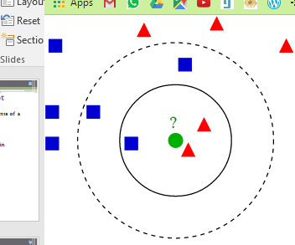

Figure 7: Demonstration of classification with different $k$’s

1. Naïve Bayes

The optimal Bayesian classifier is known to be:

$$\hat{y}=agrmax_{i} P(y_{i}|\vec{x})$$

However, estimating these conditional probabilities can be near impossible if input vectors are very high dimensional. So, a simplifying “naïve” assumption which this algorithm uses is that each feature in the input vector is conditionally independent of every other feature. Under this assumption, the optimal Bayesian classifier turns into:

$$\hat{y}=argmax_{i} P(y_{i})\prod{P(x_{k}|y_{i})}$$

Estimating these one-dimensional probabilities is a much more feasible task.

1. Decision Tree

This is a predictive model that translates answers of queries about the data to conclusions about it. The queries are represented in the branches of the tree, and the conclusions in its leaves. Decision trees are trained such that every query minimizes the variance (or maximizes information gain, equivalently) of the training samples. The classification is a series of conditions, and after all are answered, the predicted class is obtained. A decision tree is illustrated in Figure 8.

Figure 8: Example of a binary decision tree

1. Logistic Regression

Logistic regression is a probabilistic, linear classifier. It is parametrized by a weight matrix W and a bias vector b. Classification is done by projecting an input vector onto a set of hyperplanes, each of which corresponds to a class. The distance from the input to a hyperplane reflects the probability that the input is a member of the corresponding class. Mathematically, the probability that an input vector $x$ is a member of a class $i$, a value of a stochastic variable $Y$, can be written as:

$$P\left(Y=i | x,W,b\right)=softmax_{i}\left(Wx+b\right)=\frac{e^{W_{i}x+b_{i}}}{\sum{e^{W_{j}x+b_{j}}}}$$

The model’s prediction $y_{pred}$  is the class whose probability is maximal, specifically:

$$y_{pred}=argmax_{i}P(Y=i|x,W,b)$$

Training of the parameters ( $W$ and $b$) is done by a simple gradient ascent.

# Hysteresis

As in the case of radar systems and like other medical diagnosis schemes, it is critical for our system to work with low error rates. Misdetections may be fatal, and false alarms reduce the system’s reliability up to the point of not using it. We want to be very certain with every decision generated. On the other hand, a delay of a few seconds between detection and declaration is harmless.

The idea of hysteresis is to use past decisions to ascertain (or disprove) the current decision. This action verifies that a single or a few deviant decisions will not drag the system to a failure.

The mechanism, as implemented in our system, can be formulated as following.

Denote $x$– the input decision, $y$– the output decision, and $τ_{hyst}$ the hysteresis threshold.

Initialize $y$ to ‘no kid’ and counter to 0. Then, in pseudocode:

$$\begin{aligned} if x{= }^{'}kid in^{'} : counter++ \\ else if x{= }^{ '}no kid^{'}:counter-- \\ if conter≤0:counter=0, y{= }^{'}no kid^{'} \\ else if counter≥ τ_{hyst} :counter= τ_{hyst}, y{= }^{'}kid in' \\ \end{aligned}$$

The effect of hysteresis on the output decision is illustrated in Figure 9



Figure 9: Illustration of the hysteresis effect on output decisions

# Results

In this chapter, we display the obtained results, analyze the algorithm’s performance and discuss the model’s parameters. We will start from the feature extraction block, continue with the classification block and finish with the hysteresis function. A disclaimer must be told about the analysis: we use a naïve approach which assumes there is no dependence between different parameters regarding the system’s performance. In this approach, we fix all parameters of the simulation and focus each time on only one of them. Although this may be inaccurate at some points, we think it is a fair assumption, and it is the only way to sweep all of the parameter’s values (otherwise the number of runs needed is exponential in the number of free parameters).

We randomly partition the dataset (4970 samples, see page 5) to a train set and a test set, the train set being $80\%$ of the entire dataset, and run the simulation. We repeat this step for at least 20 times (50 in most cases), and average the results.

## Feature extraction block

In the next three analyses of the feature extraction block, we use a KNN classifier with $k=3$ nearest neighbors, L1 metric and inverse distance weighting. This setup has provided fairly good results, as will be shown shortly. Unless it is the inspected parameter, we fix the wavelet filter to be Daubechies 4 (db4), the number of decomposition levels to be 12 and the number of saved coefficients to be 150. The hysteresis level will be fixed to 5 outside the corresponding function’s analysis.

### Selecting the optimal wavelet

Since wavelet analysis has become a popular time-frequency method applied to a wide range of fields, an abundance of base wavelets were developed in the last decades. Seven wavelet families are documented and supported in Matlab, and each wavelet alters the transform result. A natural question is which wavelet will be most suitable for our needs. Figure 11 shows an extensive simulation of all wavelets available and their effect on the algorithm’s performance. It can be seen that the wavelet’s effect is quite moderate: The difference between the best and the worst wavelet is less than 1.5% error.

From the simulation, which is an average of 50 runs per wavelet, the best performing wavelet is Fejer-Korovkin of order 6 (fk6). This filter is illustrated in Figure 10. Why are some wavelets more suitable than others for the given task? To answer this question, we need to remember that wavelet transform is, in essence, a filtering of the signal with scaled and shifted copies of the base wavelet. And filtering, or convolution, is equivalent (up to a rotation of the filter) to a correlation between the signal and the filter. The amplitude of the transform’s coefficients is therefore a measure of similarity between the wavelets and the signal. It is eminent that for different tasks, different wavelet functions should be utilized. As to our task, a wavelet should have a high similarity to the kid signals, and a high dissimilarity to the no-kid signals. In this way, the extraction of features will transform the data to an optimal alternative space, where two classes will be clearly differentiated.

We can infer from the simulation that wavelet fk6 has the most similarity to the kid signals. In addition, we can see that for most wavelet families (Daubechies, Coiflets, bi-orthogonal), performance decreases as higher order filters are used. Here is an attempt to address this issue: The higher the filter order, higher is the number of vanishing moments, and this property is translated to higher smoothness of the filter. Since lower order filters results in better performance, it seems that the descriptive kid patterns in the signals have a relatively sharp and spiky nature. Figure 12 demonstrates the increasing smoothness (sometimes called regularity) of the Daubechies wavelet family, and the same principle holds for many other families.



Figure 10: Demonstration of the best performing wavelet



Figure 11: Performance of different wavelets



Figure 12: Demonstration of different Daubechies wavelets

### Optimal decomposition level

As described in page 10, the signal is fully decomposed to the finest levels of detail and approximation (corresponding to high and low frequencies, respectively). However, a full decomposition is not mandatory, and we may choose to stop the decomposition process at any level. This degree of freedom raises the question: what is the optimal decomposition level for our system?

Of course, this level is bounded from below by 0 (which means no decomposition at all), and from above by $\log_{2}{L}=\log_{2}{4096=12}$, where L is the signal’s length. Many works were done to address this issue (see‎[1] for example), but we believe it is enough to look at simple time-frequency considerations when deciding on this subject. We will show the simulation results and discuss them. From Figure 13 it can be observed that 8 decomposition levels are an optimal value for our specific task, by a significant difference. We can explain this result by remembering that in DWT, frequency resolution is increased and time frequency is decreased when decomposition levels increase.

As the sampling frequency is 1024Hz, the highest representable frequency is 512Hz. For a single decomposition level, we get the frequency bands [0, 256] Hz and [256, 512] Hz. For two decomposition levels, we get the frequency bands [0, 128] Hz, [128, 256] and [256, 512] Hz. By continuing to decompose the signal into bands, the lowest band is:

* [0, 4] Hz for 7 decomposition levels
* [0, 2] Hz for 8 decomposition levels
* [0, 1] Hz for 9 decomposition levels

From the simulation, we see that the transition from 8 to 9 (or more) decomposition levels did not improve performance, and we can therefore presume that frequency content below 1 Hz does not hold valuable information to the discrimination between kid and no-kid signals. It is likely that those frequencies hold only noise, and provide irrelevant information. This fits perfectly to the theory of ballistocardiography, which determines that relevant information lies in the [1, 20] Hz frequency band.

A further question is why irrelevant features decreased the system’s performance. A machine learning classifier would seemingly know to ignore irrelevant data. But we need to remember that a classifier that is trained on irrelevant information is highly prone to overfitting, and that is likely the case in our simulation.



Figure 13: Performance for all possible decomposition levels

### Optimal number of wavelet coefficients

This analysis is important because it directly affects the model’s complexity: reducing the number of features needed to adequately describe each frame positively affects both the computational complexity (time and memory) and the model’s complexity (and thus reducing the risk of overfitting). Reducing the number of features can be seen as compression of the data – keeping only the relevant and non-redundant attributes of it.

It should be reminded that apart from the raw wavelet coefficients, we also use statistical attributes of the frequency bands (see page 10); So, while surprising, it is acceptable that low error rates will be obtained even all wavelet coefficients are discarded.

We tested a dense grid for the number of used wavelet coefficients, ranging from 0 to 250. The remaining coefficients are the first coefficients, as we assume that no relevant information is stored in coefficients corresponding to frequencies above some threshold. From Figure 13 it seems that are 50 raw wavelet coefficients are sufficient in achieving optimal results. It is apparent that more coefficients cause an overfitting between the learnt model and the training set.



Figure 14: Performance for different number of wavelet coefficients

## Data classification block

In this section, we analyze the performance of six classification algorithms, optimize their parameters and discuss them. Similarity to the previous section, we fix the other block’s parameters for a consistent comparison: we use the optimal values derived for the feature extraction block (fk6 wavelet, 50 coefficients and 8 decomposition levels), and a hysteresis level of 5.

### SVM and logistic regression

These two similar algorithms were very dependent on the regularization term’s weight in terms of performance. A wide range of values were tested, however the two classifiers’ performance never exceeded a success ratio of 99.2%. Therefore, they were abandoned and did not earn documentation here.

### Naïve Bayes and LDA

Like the previous classifiers, these parameter-less algorithms too did not provide satisfactory results: they did not exceed a success ratio of 98.5% and 99.2% (respectively), and they too were neglected from our analysis.

### Decision tree

This algorithm has three tunable parameters:

* Maximal number of splits: bounds the number of node splits in the tree. If this parameter is large (close to the number of observations), then the tree will tend to memorize the training set and thus will over-fit.
* Minimal parent size and minimal leaf size: bounds the number of observations in each branch node and leaf, respectively.

The model was very sensitive to the above parameters, but in any case, did not achieve competitive results. Like other classifiers, it was abandoned.

### KNN

The last algorithm has topped other classifiers in error rates. For this reason, we will give a more detailed analysis of its behavior. This model has three tunable parameters:

* Number of nearest neighbors (K): the algorithm finds the K nearest neighbors for the observation under inspection, and decides according to the majority.
* Distance metric: defines the way in which ‘near’ is measured. Any valid metric can be used.
* Distance weight: if distances are not weighted, all K nearest neighbors have an equal vote in deciding the observation’s label. Weighting that is inversely proportional to the distance is introduced in many cases.

Shows a performance analysis for the nearest neighbor parameter, where the other two parameters are set to city block and inverse, respectively, for an average of 150 runs.

Shows a performance analysis for the distance metric parameter, where the other two parameters are set to 3 nearest neighbors and inverse weighting, for an average of 150 runs.

Shows a performance analysis for the distance weight parameter, where the other two parameters are set to 3 nearest neighbors and city block metric, for an average of 150 runs.



Figure 15: Performance as function of number of nearest neighbors

Figure 16: Performance as function of the distance metric



Figure 17: Performance as function of the distance weight

From the above simulations, we assume that the optimal parameters for a KNN classifier are: 10 nearest neighbors, a city block metric and squared-inverse weighting. Further examination revealed that this is indeed the case, and the achieved performance is an error rate of 0.31%.

It is clear why error rates decrease for more nearest neighbors and a non-equal weighting: it promotes reliance on more observations (and thus has robustness to outliers) while reducing the risk of overfitting to the many observations (because of the weighting scheme). However, interesting and not immediate is why the city block metric (a nickname for the $L_{1}$ norm, also called Manhattan or taxicab distance) provided the best results. One possible explanation is linked to the curse of dimensionality. It is well-known (and also discussed in ‎[4]) that in high dimensional space the data becomes sparse, and traditional indexing and algorithmic techniques fail from efficiency and/or effectiveness perspective. Not only that our feature space is high dimensional, it is also known that coefficients derived from a wavelet transform are sparse in nature.

Define the *relative contrast* of a d-dimensional feature space with an $L_{p}$ norm as the ratio of the difference between the maximal and minimal distances (to a given query point) to the minimal distance. Than from ‎[3], we know that under some broad conditions, the relative contrast goes to zero in high dimensional spaces, for any norm $L_{p}$. Or, formally:

$$\frac{Dmax_{d}^{p}-Dmin_{d}^{p}}{Dmin_{d}^{p}}→_{p}0$$

The relative contrast of a feature space is regarded as a quality of meaningfulness of a proximity query. Furthermore, the convergence rate is faster for higher $p$-normed spaces. Thus, for higher dimensionality, the relative contrast provided by a norm with smaller parameter p is more likely to dominate another with a larger parameter. Consequently, [3] and‎[5] argue that among the distance metrics with integral norms, the Manhattan distance metric is the method of choice for providing the best contrast between the different points. These works could give some insight to the reason that $L_{1}$ outperformed all other distance measures.

## Tuning the hysteresis level

According to page 15, this hyper parameter has a crucial affect not only on the system’s performance, but also on the detection time. It confronts us with a tradeoff between low error rates, and fast detection times. Each hysteresis level is equivalent to a delay in detection of two seconds. In the case of detection times for children in cars, it is safe to assume that a few seconds of delay are harmless. However, in any way, we present here the performance for different hysteresis levels, and leave the tradeoff open for personal interpretation.

Figure 18 shows the system’s error rates for all practical hysteresis values. Simulation was done with the optimal parameters from previously inspected blocks. The parameters are listed here for completeness: fk6 wavelet, 50 wavelet coefficients, 8 decomposition levels, KNN classifier and 10 nearest neighbors with city block metric and squared-inverse weighting.



Figure 18: Performance as function of the hysteresis level

It is not surprising that error rates decrease as hysteresis levels increases. It is also not surprising that at some point, this procedure will cause more harm than good, and we can see that this happens for a value of 14. At this point the algorithm responds too slow to changes. The optimal performance was 0.07% for both errors (0.03% false alarms, 0.04% miss-detections).

## Error analysis

In the last section, we showed that the system achieves an error rate of 0.07% per frame. While it sounds like satisfactory performance, it may be worthwhile to analyze what caused these errors. An analysis like this could shed light to how to algorithm works and how we can improve it. We looked at the errors on an experiment level, and even on a data frame level (and not on a dataset level, as was done before), and we found the following facts:

* 84% of the experiments were correctly classified for all frames, time and time again
* 12% of the experiments had classification errors only for some runs
* The rest were consistently misclassified

Looking at the set of experiments that were consistently misclassified, we saw that errors did not come in long bursts: the maximal sequence of consecutive errors was only 2 frames.

The plausible explanation for most simulation errors is imperfections in the dataset. As mentioned in page 5, kid data was mostly acquired inside a kindergarten, on a large sofa. Kids woke up from their afternoon nap and were excited to see their parents. They were very active, and most did not sit still on the sensor. This scenario is not perfect for the task – forgotten children are likely to be asleep or at least very still.

Obviously, some errors are introduced because of model imperfections and noise. However, we believe that a cleaner, more relevant database would prove the proposed method to have significantly better results.

# Passenger detection

Another application of this system is the detection of passengers (not necessarily children) on seats in driving cars. Discriminating between a human passenger to an empty (or loaded) seat can significantly improve the poor false positive rates of common seat belt detectors. However, this seems a greater challenge when compared to the main objective of detection in still cars, as driving induces heavy noise to the signal measurements.

We decided to take advantage of the opportunity to measure different scenarios, and so we recorded more than 90 minutes worth of signals of an adult sitting on a sensor while driving, and a similar amount of signals of a heavy (4 kg) bag on the sensor while driving. We drove both in the city (Haifa is known for its bumpy roads) and on highways.

Figure *19* demonstrates the different qualities of the signals from both scenarios. Note that the magnitudes of the signals are similar.



Figure 19: Demonstration of the difference between signals of passengers and empty seats while driving

The following section summarizes the main results from this experiment. Since this application was not the primary focus of our project, we did not execute a full-scale optimization for all participating parameters. Rather, we assumed that previously obtained parameters will give favorable results in this case, too. Also, this chapter is brought merely as a proof of concept, so global optimality was not our foremost consideration.

Figure 20 shows the results. As said above, the parameters used are the same as in page 25.



Figure 20: Performance as function of the hysteresis level for a driving car

Like before, performance improves with increasing of the hysteresis. As opposed to the child detection case, here a delay in detection is less acceptable. Error rates reach almost 0.8%, but only after a delay of more than half a minute. We therefore conclude from this preliminary test that error rates lie around 1%, depending on the acceptable delay in detection.

# Real Time Implementation

Aside from the Matlab based simulation environment, we have also implemented an operational machine learning algorithm on a microcontroller. It generates ‘kid’ or ‘no-kid’ decisions every 2 seconds. The implemented algorithm consists of three parts: wavelet transform based features (see page 9), a linear discriminant analysis classifier (see page 12), and a hysteresis smoothing procedure (see page 15), a combination which was also tested in the simulation phase. The LDA classifier was chosen for its simplicity, and the other elements were selected because they were presumed to give favorable results before the optimal solution and parameters were found in the described simulation. It is documented in page 32.

# Discussion and Conclusion

In this work, we developed a machine learning based system for the detection of children forgotten in cars. Our work involved each and every phase in the development:

* We acquired a diverse dataset of more than 10 hours of recordings.
* We developed a machine learning and feature extraction simulation, for which we executed a full scale optimization.
* We implemented a real-time operational version of the algorithm on a standalone microcontroller.

Our work showed that child detection in cars can be done with error rates as low as 0.07% - that is one error every 1400 data samples, or a single error every hour. While not perfect for practical use, these are impressive results for a first attempt. We believe there is much room for future improvement. One direction could be more sophisticated and manually customized feature engineering. Another possibility is the use of dimensionality reduction methods, linear or not, to remove redundant and irrelevant information (As we’ve seen that many problems arise from high dimensionality). Enlarging the dataset should also have a positive effect on this issue. And of course, it will be interesting to see the performance of deep learning models on this task.

# Bibliography

1. Starr, Isaac, and Abraham Noordergraaf. Ballistocardiography in cardiovascular research: Physical aspects of the circulation in health and disease. Lippincott, 1967.
2. Lei, Chao Wang, and Xin Liu “Discrete Wavelet Transform Decomposition Level Determination Exploiting Sparseness Measurement” International Journal of Electrical, Computer, Energetic, Electronic and Communication Engineering Vol: 7, pp. 1182–1185, 2013.
3. Beyer K., Goldstein J., Ramakrishnan R., Shaft U.: When is Nearest Neighbors Meaningful? ICDT Conference Proceedings, 1999.
4. C.C. Aggarwal, A. Hinneburg, and D.A. Keim. On the surprising behavior of distance metrics in high dimensional space. In Proceedings of the 8th International Conference on Database Theory (ICDT), pages 420–434, London, UK, 2001
5. A. Hinneburg, C. C. Aggarwal, and D. A. Keim. What is the nearest neighbor in high dimensional spaces? Proceedings of the International Conference on Very Large Databases (VLDB), pages 506–515, 2000.

# Appendix A: Project Documentation

This section provides a detailed summary of all functions, tools and data used in this project. It is provided mainly for the use of other students or researchers who are interested in the framework of this project.

**Matlab simulation – description of components**

The machine learning simulation was constructed in a Matlab environment. It includes the following functions and scripts:

1. SimulateKidML – The main simulation function. It can be operated both as a script (no input arguments) and as a function. All simulation parameters are packed in a designated structure, simParams. This structure is further broken down by sub structures according to the simulation block, for example simParams.general and simParams.dataClassify. The general simulation parameters are: a flag to draw plots, a flag to add noise, data segment length and the dataset on which to train and test. More parameters are needed for each block, and will be specified in the corresponding function details. The main simulation blocks are: preprocessing (‎b), feature extraction (), classification () and result display and analysis.
2. DataPreprocessing – This function implements the preprocessing block. It is called by the main simulation environment (‎a). Its input is only the simulation parameters and its main function is to organize the dataset according to the segments’ length. It outputs TrainArr, a matrix of all data (not yet partitioned to training and testing set), where each column is a different segment. Apart from that, it also outputs an array specifying what experiment the segment originated from (ExpArr), an array specifying the ground truth label for each segment (species), and finally a binary array specifying if the corresponding segment can be used to test performance or not (ok4TestArr).
3. AddNoise – This function implements the addition of synthetic noise to the dataset’s segments. It is called by the main simulation environment (‎a), right after the preprocessing block (‎b). It adds noise only if simParams.general.addSynthNoise is set to ‘normal’ or ‘no kid’. The noise’s power is set according to the parameter simParams.general.noiseSTD, and if it is set to 0 than the power is set to be the standard deviation of the signal. As the parameter implies, the noise type can be white Gaussian, or a no-kid signal which is added to other signals.
4. FeatureExtraction – This function implements the feature extraction block of the simulation, according to page 10. It is called by the main simulation environment (‎a). its’ inputs are the simulation parameters and the dataset’s matrix, TrainArr. It outputs a matrix of features, where each column is a transformation of the recorded signal according to the simulation parameters. Currently this block supports only wavelet based features. Possible parameters to tune include the wavelet filter (e.g. db4), the decomposition level and the number of transform coefficients to leave.
5. DataClassification – This function is responsible for training the train set, classifying the test set and evaluating the model’s performance. It is called by the main simulation environment (‎a). It inputs all previously used variables (TrainArr, species, ExpArr, ok4TestArr and the simulation parameters) and outputs two performance measures: false alarm and misdetection rates (probabilities). Its tunable parameters are the classifying model and its parameters, the percentage of test signals out of the entire dataset and the hysteresis level (see page 15). Another important parameter is the number of times for which to repeat the training and classification procedure. Since every iteration randomly shuffles the train and test set, it is important to repeat this action for a few times and average the results in order to remove noisy results. On a side note: performance is not evaluated for the first ‘hystLevel’ segments, because these labels are considered garbage.
6. DisplayResults – This function analyzes the previous block’s results and displays them in a convenient and meaningful way. It allows to see for each experiment if it was classifying correct or false, and by what probability. We did not use this function in the system’s design, and so it has not been updated for some time.
7. ShowSignals – An auxiliary script used to view raw recordings. Insert a pathname and an experiment number to open a comparative view of the signals.
8. CompatibilityCheck – A script used to assure the identity of results between matlab simulation and Arduino algorithm. It replicates the microcontroller’s operation on a sequence of data and generates results in the same manner that the Arduino board does.

**Data**

Here is a guide to all data used in this project.

1. NewData – a folder by this name contains all data recorded by us from April to June, 2017. This folder is partitioned to ‘kid’ and ‘no kid’ folders. The former contains all data where a human was recorded (not necessarily children) and the latter contains all data that has no human involvement. In each of above folders is a collection of folders, titles according to the recording scenario. And in these folders, lies the recordings, in excel format. Each folder also contains a short readme file detailing the recording scenario.
2. OldData - a folder by this name contains a long sequence of signals, not recorded by us. Inside the folder there is another excel file called ‘ground truth’, which contains, as the name implies, the label for each of the experiments in the folder. An unknown or absent label will receive the number -1. The credibility of this dataset is disputed - we were told that the recordings are not of a high quality.

**Arduino**

This section documents all parts of Arduino design environment. There are a few Arduino files (.ino) and each contains one or more functions. Most functions were not developed by us - we focused on implementing the detection algorithm.

1. mainv1_5_4_final_ver – This is the main function. It contains the setup and loop blocks that are present in every Arduino program, and all other functions are called from it. The setup includes: define macros, output and input pin modes, includes of headers and a call for more setup functions. The loop contains a call for the data loading function, a call for the detection function and a call for the hysteresis function. If decision of a kid in a car is made, the action function is called. Apart from that, it contains the following functions outside the loop: load_data (responsible for moving the samples data to two arrays: each time one array is processed while the other one is being refreshed) and check_relay (Checks that all relays work)
2. adc_setup­ – This file includes several functions dedicated for the proper action of the analog to digital converter. We were warned by its developer not to touch it, so we pass on this recommendation.
3. output_handle – This file deals with what action should be taken for each decision. Its main function is make_action which is called every loop cycle. If a kid decision is made, this function turns on the light, window, door and horn relays.
4. detect_algo_over_time – This is the first attempt for a fixed decision rule. Its principal is using an energy ratio in the time domain.
5. detect_algo – This is the second attempt for a fixed decision rule. Its principal is using an energy ratio in the frequency domain (see page 9).
6. Detection_algo_tomli – This is our attempt for a detection algorithm, described in detail in this document. Its main function is child_detect_tomli, which calls the data normalization function dataConversion, the wavelet transform function daub4_transform, and finally implements an LDA decision rule based on coefficients stored in ldaCoeffs.h.

**Data Acquisition**

This section instructs how to record new data. The procedure is quite easy:

1. Download LabView. Register for a free student license.
2. Download drivers for the NI-6002 data acquisition probe.
3. Connect the probe and open the LabView recording application. Its name is ‘high resolutio_REC 1 -Doron’ and it is found in the ‘data’ folder of the project archive.
4. Press ‘Enable’ and set the sampling frequency to 1000Hz. Specify the folder for the recordings to be saved.
5. Press the play icon to start a recording, and the stop button to stop and save it. Every time play is pressed, a new file will be generated.
6. Don’t forget to label the recorded data!

**Matlab simulation – simulation manual**

In order to run any kind of simulation, open directory code\Matlab\Main ML simulation\.

The main simulation function is SimulateKidML.m.

There are three basic types of simulation. We’ll elaborate instructions for each one of them. But first, there’s a general preparation, in which you choose data folders to withdraw data from:

simParams.general.dataset variable holds paths for all relevant data directories. You may add some, or comment out some of the existing ones. Each folder line contains additional information, you need to define: {'<directory path>'} {X} {Y}

X - represents the label of the directory (ground truth). Write 0 for “no kid” tag, and “1” for “kid” tag.

Y – represents whether it’s ok to use data from this folder for test runs. If assigned 0, data from this folder will be used only for training (default is 1).

After setting the dataset folders, we can run simulations:

1. Basic simulation with a single final result (all parameters are fixed)
   1. Simulation Parameters section: assign all desired values
   2. Feature Extraction section: make sure the function call is **not** commented out
   3. Data Classification section:
      1. Assign **parameterName** and **simName**
      2. Make sure **parameterGrid** is assigned with a simple “1” value (or any other arbitrary number, it doesn’t matter)
      3. Make sure assignments to **simParams** and **features** variables inside the for loop are commented out
   4. Run the simulation (F5)
2. Run parametric simulation, for parameter that requires only one feature extraction for all iterations. Generally speaking, those would be parameters who belong in simParams.dataClassify.
   1. Simulation Parameters section: assign all desired values
   2. Feature Extraction section: make sure the function call is not commented out
   3. Data Classification section:
      1. Assign **parameterName** and **simName**
      2. Assign **parameterGrid** with a list of the elements you like to test
      3. Inside the for loop:
         1. Uncomment **simParams** assignment
         2. Make sure assignment to features is commented out
   4. Run the simulation (F5)
3. Run parametric simulation, for parameter that requires a new feature extraction in every iteration. Generally speaking, those would be parameters who belong in simParams.features.
   1. Simulation Parameters section: assign all desired values
   2. Feature Extraction section: comment out **features** assignment
   3. Data Classification section:
      1. Assign **parameterName** and **simName**
      2. Assign **parameterGrid** with a list of the elements you like to test
      3. Inside the for loop:
         1. Uncomment **simParams** assignment
         2. Uncomment **features** assignment
   4. Run the simulation (F5)